 | De La Salle University  College of Computer Studies  Ethical Hacking
Module No. 4 – Enumeration

Name | : |  | Daniel Gavrie Clemente

Objectives
- To understand the concept of enumeration
- To understand how services on a host can be exploited to gain information on target hosts

Procedure

Initial Setup
- Set up three machines (whether physical or virtual) with the following specifications :
Machine | Operating System | IP Address/Subnet Mask
Hacker – Linux | Kali Linux | 172.16.15.x/24
Victim – Windows | Windows 7 | 172.16.15.1x/24
Victim – Metasploitable | Metasploitable Linux  Username: msfadmin  Password: msfadmin | 172.16.15.2x/24
- Take a snapshot of your Windows 7 Machine before making any changes.
- Extract the file from script.zip to your Windows 7 Desktop with a password of “infected”.
- To run the script, open a PowerShell and run it as Administrator. 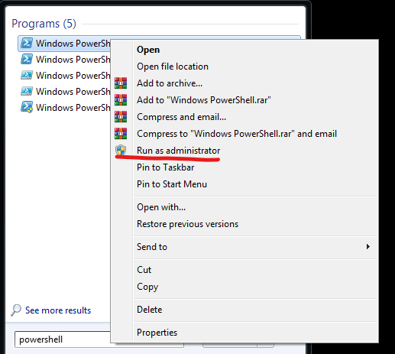
- Change the directory to Desktop and run the following commands:
Set-ExecutionPolicy Bypass -Scope Process -Force
.\smb-enum-script.ps1
- Go to Control Panel > Network and Internet > Network and Sharing Center > Advanced sharing settings. Turn off the password protected sharing and save changes.
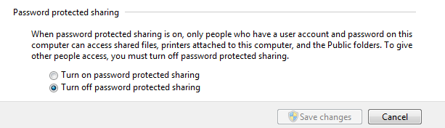

Using nbtscan and smbclient
- Open a terminal application in the Kali Linux system.
- On the command prompt, type in “nbtscan 172.16.15.0/24”.
- What are the NETBIOS names of the computer?
WIN-AHAJBHIP7GK - Windows 7
METASPLOITABLE - Metasploitable

- On the command prompt, type in “smbclient –L=[Metasploitable Linux IP address]”.
Enter a blank password if prompted.

- Were you able to see the shared folders without entering a password on the Metasploitable Linux machine? Why? (Hint: Research null scan on Windows-based computers on the Internet)
Yes, because Metasploitable Linux is intentionally configured with insecure settings, including open and unprotected services like SMB (Server Message Block), which is commonly used for file sharing.

- List down shared folders of the Metasploitable Linux machine, if there are any.
Sharename Type Comment
--------- ---- -------
print$ Disk Printer Drivers
tmp Disk oh noes!
opt Disk
IPC$ IPC IPC Service (metasploitable server (Samba 3.0.20-Debian))
ADMIN$ IPC IPC Service (metasploitable server (Samba 3.0.20-Debian))

Enumerating users and shares - NMAP
- Open a terminal application in the Kali Linux system.
- At the command prompt, type in the command “nmap --script=smb-enum-users [Metasploitable Linux IP address]”
- List down the discovered users on the Metasploitable Linux below:

Discovered Users
Enabled Users:
msfadmin
user
Disabled Users:
backup
bin
bind
daemon
dhcp
distccd
ftp
games
gnats
irc
klog
libuuid
list
lp
mail
man
mysql
news
nobody
postfix
postgres
proftpd
proxy
root
service
sshd
sync
sys
syslog
telnetd
tomcat55
uucp
www-data

- At the command prompt, type in the command “nmap --script=smb-enum-shares [Metasploitable Linux IP address]”
- List down the discovered shares on the Metasploitable Linux below:
Discovered Shares
ADMIN$
IPC$
opt
print$
tmp

- What does a shared folder with “$” mean? (You may search for this on the Internet)
A folder or network share name ending with a dollar sign ($) is known as a hidden share in
Windows and SMB (Server Message Block) environments.

- At the command prompt, type in the command “nmap --script=smb-enum-groups [Metasploitable Linux IP address]”
- List down the discovered groups on the Metasploitable Linux below:
Discovered Groups
There are currently no discovered groups on Metasploitable Linux.

Enumeration on Windows 7 Machine - NMAP
- Open a terminal application in the Kali Linux system.
- At the command prompt, type in the command “nmap --script=smb-enum-users [Windows 7 IP address]”
- List down the discovered users on Windows 7 below:

Discovered Users
Administrator
DLSU_User
gavri
Guest
HomeGroupUser$
student

- At the command prompt, type in the command “nmap --script=smb-enum-shares [Windows 7 IP address]”
- List down the discovered shares on Windows 7 below:
Discovered Shares
ADMIN$
C$
IPC$
Users
Hackme
public

- At the command prompt, type in the command “nmap --script=smb-enum-groups [Windows 7 IP address]”
- List down the discovered groups on the Metasploitable Linux below:
Discovered Groups
Builtin\Administrators
Builtin\Users
Builtin\Guests
Builtin\Power Users
Builtin\Backup Operators
Builtin\Replicator
Builtin\Remote Desktop Users
Builtin\Network Configuration Operators
Builtin\Performance Monitor Users
Builtin\Performance Log Users
Builtin\Distributed COM Users
Builtin\IIS_IUSRS
Builtin\Cryptographic Operators
Builtin\Event Log Readers

Banner Grabbing - HTTP
- Open a terminal application in the Kali Linux system.
- At the command prompt, type in the command “telnet [Metasploitable Linux IP Address] 80 “. You should see a connected message.
- When connected, type in the following :
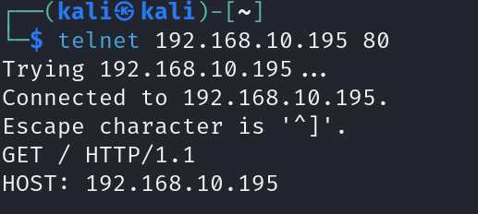
- What information can you gather about the web server?
This is a Metasploitable 2 web server running Apache and PHP on Ubuntu, hosting multiple intentionally vulnerable web applications that are ideal targets for SQL Injection, XSS, Command Injection, File Upload Exploits, and WebDAV attacks.

- What is the software name and version of the web server used by the target host?
Web Server Software: Apache
Version: 2.2.8
Platform: Ubuntu Linux
Additional Modules:
- DAV/2 (WebDAV enabled)
- PHP/5.2.4-2ubuntu5.10 (as the backend scripting engine)

SMTP Enumeration Part 1
- Before starting SMTP enumeration, research what the « netcat application can do on the Internet. What is the “netcat” application?
Netcat (often abbreviated as nc) is a powerful networking utility used by system administrators, network engineers, and ethical hackers. It's often referred to as the “Swiss Army knife” of networking.

- Open a terminal application in the Kali Linux system.
- At the command prompt, type in the command “nc [Metasploitable Linux IP address] 25”. You should see a message “[*] 192.168.25.128:25 Banner: 220 metasploitable.localdomain ESMTP Postfix (Ubuntu)” when you are connected.
- At the prompt, type in the command “vrfy root”. What is the output? Does this indicate that the user exists?
After typing in the command “vrfy root,” the output is “252 2.0.0 root.” The output does indicate the user exists.

- At the prompt, type in the command “vrfy user1”. What is the output? Does this indicate that the user exists?
The output is
“550 5.1.1 <user1>: Recipient address rejected: User unknown in local recipient table.”
The output indicates the user doesn’t exist.

- At the prompt, type in the command “vrfy msfadmin”. What is the output? Does this indicate that the user exists?
The output is “252 2.0.0 msfadmin.” The output does indicate the user exists.

- Is it possible to enumerate the users through the SMTP protocol?
Yes, it is possible to enumerate users through the SMTP protocol.

SMTP Enumeration Part 2
- Open a terminal application in the Kali Linux system.
- At the command prompt type in the command “smtp-user-enum -M VRFY -U /usr/share/wordlists/fern-wifi/common.txt -t [Metasploitable Linux IP address]”

- What are the usernames discovered?
lp
root
service
sys
user
MAIL
Root
SERVICE
SYS
Service
User

- Was the “msfadmin“ username found? Why?
No, the msfadmin username was not found in the SMTP enumeration result because msfadmin was not found because it probably wasn't in the wordlist.

- Edit the file “/usr/share/wordlists/fern-wifi/common.txt” to include the msfadmin username. After editing, run the script again. Was it able to discover the msfadmin username? Why?
Yes, because the msfadmin username was added to the wordlist, allowing the enumeration tool to explicitly check for it against the SMTP server.

Guide Questions:
- What is enumeration? How can this technique help in investigating the network?
Enumeration is the process of actively connecting to a system and gathering detailed information, such as users, shares, services, and more, which helps in identifying potential vulnerabilities in the network.
- What information can be gathered using Nmap SMB scripts and SMTP scripts? Why is this possible?
Nmap SMB and SMTP scripts can gather data like shared resources, user accounts, domain information, and email server configuration because they interact with exposed service ports that respond with such details.
- What information can be gathered from banner grabbing web servers? Why is this possible?
Banner grabbing web servers can reveal software versions, server types, and operating systems because servers often send this information in HTTP headers during connections.
- What information can be gathered from an SMTP server? Why is this possible?
SMTP servers can provide user enumeration, mail relay status, and software versions because they respond with detailed messages to SMTP commands during connection attempts.
- What other tools can you use (whether for Linux or Windows) to do enumeration?
Other enumeration tools include Netcat, Enum4linux, SNMPwalk, RPCclient, LDAPsearch, and PowerView (for Windows), as they can query various services and protocols for detailed network and system information.

Resources:

Kali Linux - Hacker Machine
https://www.kali.org/get-kali/

Metasploitable 2 - Victim Machine
https://sourceforge.net/projects/metasploitable

Windows 7 Victim Machine
https://drive.google.com/drive/folders/16lKVVJxEVBbIIu1AspjglaZ1bLh7yZMe?usp=sharing

SMB Enum Script for Windows 7
https://drive.google.com/file/d/1Xd8A0vCq7m3pq7zFb1_dfCvaOuzy_HYl/view?usp=sharing
*Password - infected

